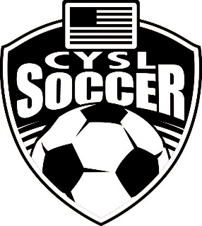

Clearlake Youth Soccer League
P.O. Box 721
Middletown, CA
95461

Contacts:

President: Lamar Jones
President@clearlakeysl.com

Vice President: Christina Thomas
Vicepresident@clearlakeysl.com

Secretary: Jessica Jones
Secretary@clearlakeysl.com

Treasurer: Gina Smith
Treasurer@clearlakeysl.com

